Practices for Secure Software Report
Algorithm Cipher
For this project, the best overall choice was to use HTTPS with TLS for secure communication and SHA-256 for the checksum verification step. AES is commonly used through TLS because it is fast, strong, and practical for protecting data during transfer. It is a symmetric encryption method, which means the same session key is used to encrypt and decrypt the data once the secure connection is established. That makes it a strong fit for web communication.
SHA-256 was the right choice for the checksum part of the project because it provides a consistent 256-bit hash value that can be used to verify data integrity. It is not used to encrypt data, but instead to confirm that the data has not been changed. That matters here because Artemis Financial wanted a verification step when data moves through the application. Older algorithms such as MD5 and SHA-1 would not be a good choice because they are weaker and no longer considered strong enough for modern security needs.
There is also an important difference between symmetric and asymmetric encryption. Symmetric encryption is faster and works well for actual data transfer. Asymmetric encryption uses a public and private key pair and is useful for certificates, identity, and secure key exchange. In this project, the self-signed certificate helped support HTTPS, while SHA-256 handled the integrity check.
Certificate Generation
I generated a self-signed certificate using Java Keytool and stored it in a PKCS12 keystore file. After generating it, I exported the certificate as a CER file. The certificate details showed that it was issued to Sebastian Alfsen, issued by Sebastian Alfsen, and had a valid date range for local testing. This was important because the application needed a certificate to support HTTPS on the local server.
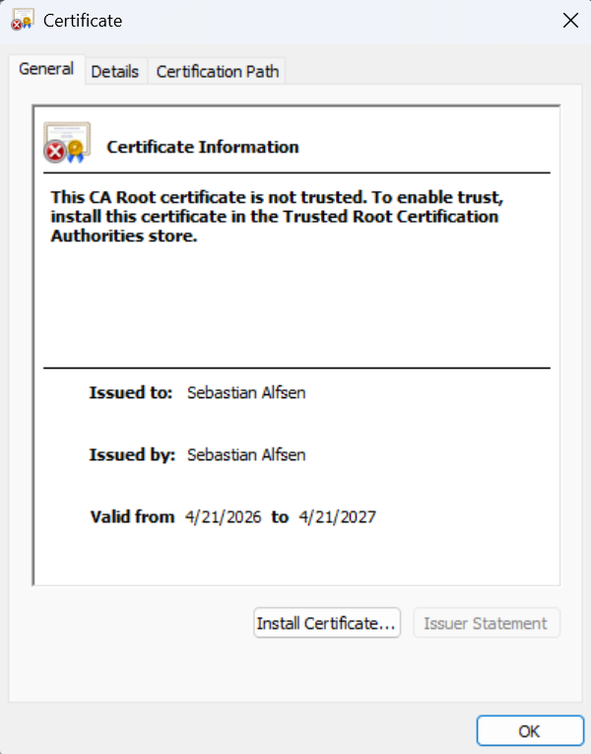

Deploy Cipher
To deploy the checksum feature, I refactored the code so the application returns a SHA-256 checksum at the /hash route. I used a unique test string that included my name so the output would clearly show that the route was working and that the checksum was based on the correct data. This added the data verification step the client requested.
When the route was tested in the browser, the page displayed both the original data string and the SHA-256 checksum. That confirmed the cryptographic hash function was working correctly and that the application could now verify data integrity through a checksum.
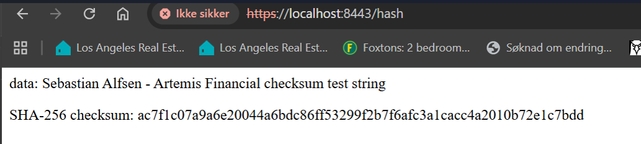
Secure Communications
I also updated the application so it uses HTTPS instead of HTTP. To do that, I filled in the SSL settings in the application properties file and pointed the application to the keystore file stored in the resources folder. I configured the application to run on port 8443.
After the changes, the Spring Boot application started successfully with HTTPS enabled. I then opened https://localhost:8443/hash in the browser and confirmed that the secure page loaded correctly. Since the certificate is self-signed, the browser showed that it was not fully trusted, which is expected for a local development environment. Even so, the application was clearly using HTTPS and returning the checksum output through a secure connection.
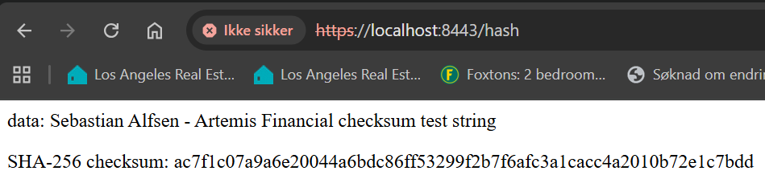
Secondary Testing
After refactoring the application, I ran OWASP Dependency Check as a secondary static test. The scan completed successfully and generated an HTML report. The report still showed multiple vulnerable dependencies, but these were tied to the older Spring Boot and framework libraries already included in the provided project. That includes dependencies such as Spring Boot, Spring Framework, Tomcat, SnakeYAML, Jackson, and Logback.
What stood out most is that the small refactoring changes I made did not add any new third-party dependency to the project. In other words, the scan still found inherited vulnerabilities in the original project stack, but not a new dependency vulnerability caused by the checksum endpoint or the HTTPS configuration I added.
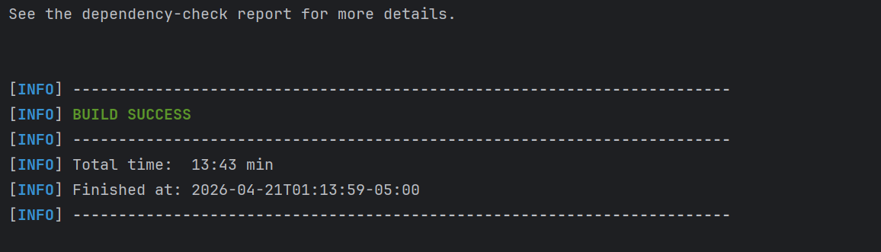
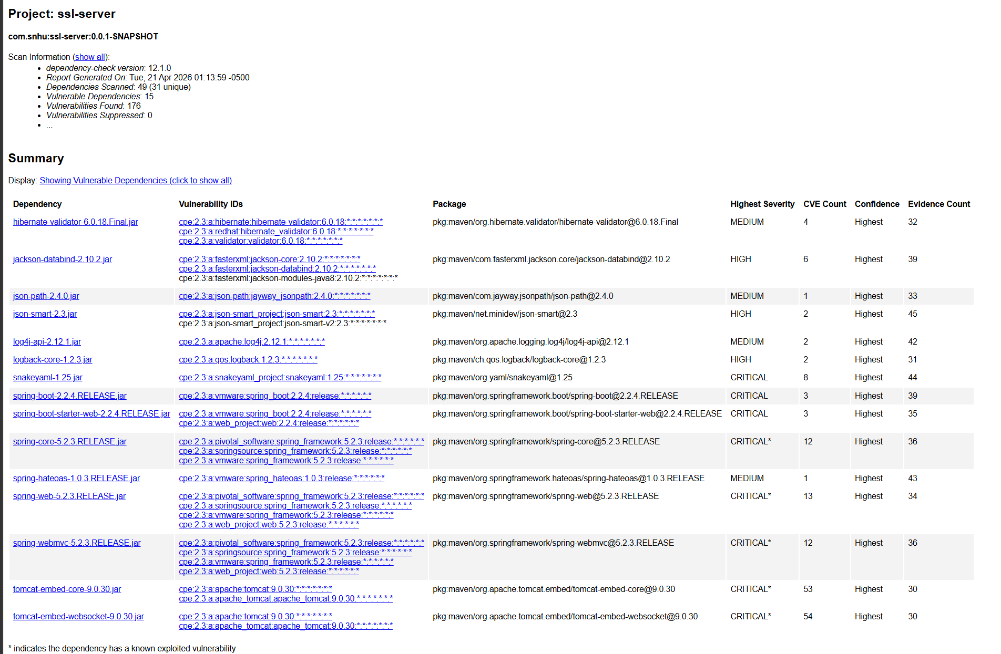
Functional Testing
I manually reviewed the code and also tested the application by compiling and running it. The application started without errors, the default test completed successfully, and the secure /hash route returned the expected output. That confirmed the code changes were syntactically correct and logically working.
From a security point of view, the main weaknesses in the starter project were the missing checksum route, the incomplete SSL configuration, and the lack of secure transport. I addressed those directly by adding the SHA-256 checksum endpoint, configuring the keystore, and changing the application to HTTPS. The remaining issues found during the dependency scan were part of the older dependency stack in the provided project and not caused by the new code I added.
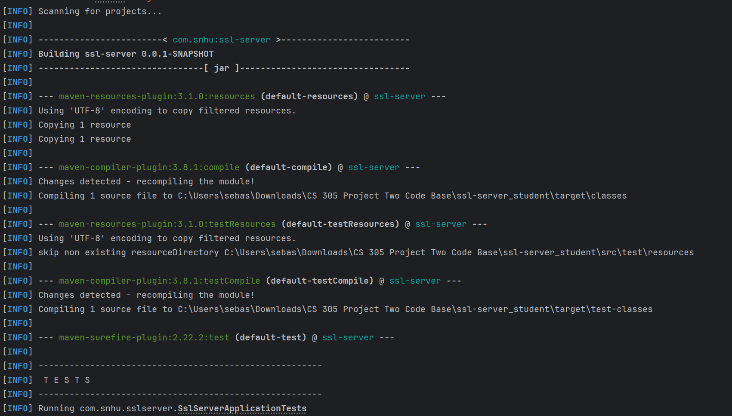
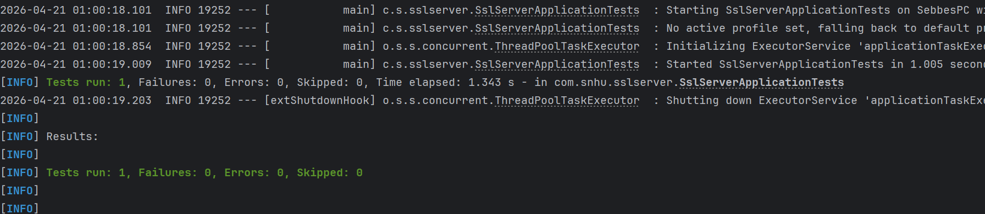

Summary
This project added multiple layers of security to the Artemis Financial application. First, I added a SHA-256 checksum route to support integrity verification. Second, I generated and exported a self-signed certificate and configured the application to use HTTPS on port 8443. Third, I ran a secondary dependency check after the refactoring to review the updated application.
One thing that stands out is that the application now has both transport security and integrity verification instead of relying on only one protection. HTTPS helps protect data while it is being transmitted, and the checksum helps verify that the data itself has not been altered. Together, those changes give the application a stronger security setup than it had at the start.
The application compiled, ran successfully, and returned the checksum through a secure page. The dependency check, also completed successfully. While the report still showed inherited vulnerabilities in the original outdated dependency stack, the refactoring itself added the required security controls without introducing new libraries.
Industry Standard Best Practices
I applied industry standard secure coding practices by using HTTPS instead of plain HTTP, using a certificate-based SSL setup, using SHA-256 instead of weaker hash functions, and running static testing after the code changes were complete. I also kept the changes focused and limited to the requirements instead of adding unnecessary complexity.
The value of following these practices is that they help protect confidentiality, integrity, and trust. For a financial company like Artemis Financial, that matters because the application deals with sensitive client and financial information. Secure communication reduces the chance of exposed data during transfer, and checksum verification adds another layer by helping confirm the integrity of the transmitted data. Even though the original framework stack still has inherited dependency issues that would need future upgrades, the refactoring improved the application’s security posture in a practical and meaningful way.

